**Web Development Tutorials for Beginners in Hindi** by codewithharry

* Introduction
  + Prerequisite: Complete Beginners
  + What is html
    - HTML stands for Hypertext Markup Language
    - It is basically a standard markup language for giving a static skeleton to web application and websites.
    - Its a well standardized system
  + What is CSS
    - Cascading Style Sheets which is known as CSS is a style sheet language that used to handle the presentation of the web page containing HTML.
    - It makes our websites beautiful and modern looking.
  + What is JavaScript
    - JavaScript, which is often known as JS, is a high-level dynamic interpreted programming language.
    - It allows client-side scripting to create completely dynamic web applications and websites.
  + How website works
    - Website
    - Server
    - IP/Domain
  + Frontend vs Backend
* HTML
  + Preparation for writing html
    - Text editor
      * VS code
        + Download & Install
        + Open folder in VS code
        + Create file with .html extension
        + Auto Complete basic with “emmet Abreviation” using “!” sign. Its also called boiler plate or template.
        + Explorer, search git and extension in VS code.
        + Download “live Server” and click “go live” it will show web on localhost browser in Realtime without manual reloading.
        + Enable Editor: Mouse Wheel Zoom
        + Shortcut keys
        + Boiler plate
        + Code folding
        + Wrap text using toggle word wrap from setting>command pallet
        + P*4 : to add 4 pera tags
        + Use control + enter to go to new line.
        + Alt+click : used to add multiple cursur
  + Basic Structure of HTML
    - <!DOCTYPE html>
    - Tags: <> </>
    - Attribute
    - <head>Meta tags, metadata, titles, external sheets link</head>
    - <body></body>
    - <!—Type Comments here > , use control + forward slash “/” to convert line into comment.
  + Lec4-Head.html
    - <meta charser=”UTF-8”> : meta tag used in seo, use to increase web traffic, meta description tag,
    - Resposive Design encourage
    - Ie=edge,
  + Lec5-Body-heading.html
    - <h1>…..<h6> tags for heading, don’t use heading tags to bold something.
    - <p>for peragraphs</p>
    - <strong></strong>
    - <em></em>
    - <br> : used to break line, go to next line, this not best practice
    - <hr>: is used to add horizontal line
    - <b>This is used to bold</b>: use strong instead of bold and em instead of italic
  + Lec6.html
    - Ancher tags: used to add links: <a href=”link”>Text</a>  
      e.g. <a href=”https://google.com”>Go to Google</a>
      * Add attribute to open link in new tab: target=”_blank”  
        e.g. <a href=https://google.com” target=”_blank”>Go to Google</a>
    - Add internal Links: <a href=”/file-name”>Text</a>
    - Add Images: <img src=”image-path” alt=”Text shown in case image failed to load or not present”>  
      e.g.: <img src="/Images/aqib.png" alt="Error Loading Image">  
      e.g.: <img src="https://source.unsplash.com/400x100/?nature,water" alt="unsplash Error Loading Image">
    - Add attribute to adjust width and height: <img src=”/path” alt=”text” width=”number” height=”number”>  
      e.g.: <img src="/Images/aqib.png" alt="Error Loading Image" width="200" height="200">  
      It is not recomended to use html for sizing, we will be using css for that.
  + Lec7-Lists and Tables
    - Lists (Bullets and Numbering )
      * Ordered List (Numbering List): <ol>: used to add lines with numbering system   
        <ol>  
         <li>This is First item of my order List</li>  
         <li>This is Second item of my order List</li>  
         <li>This is Third item of my order List</li>  
         </ol>  
        shows   
        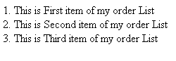
        + Type attribute of order list: <ol type=”1”> :it dectates the numbering system such as below   
          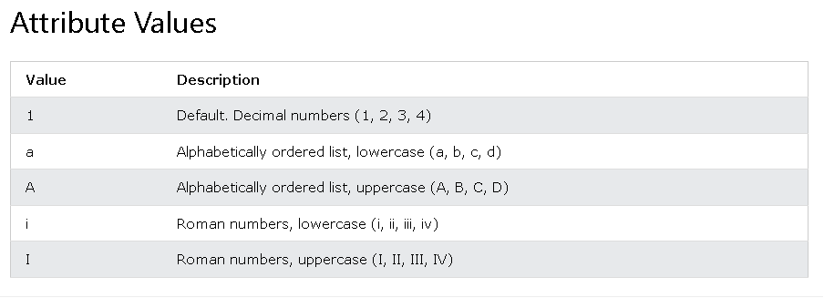
      * Un Ordered List (Bullets): <ul>
        + Style Attribute of <ul> : <ul style=”list-style-type: style-name">  
          e.g.: Style Attribute of <ul> : <ul style=”list-style-type: circle">  
          There are also others such as “disk”,”square”...  
          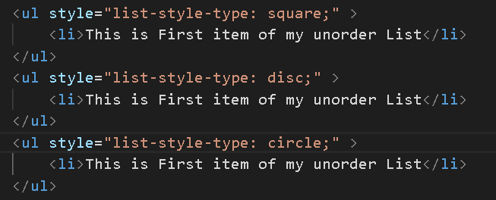  
          Shows   
          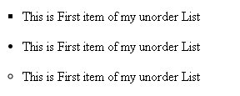
      * Nested Lists: Lists Inside List  
        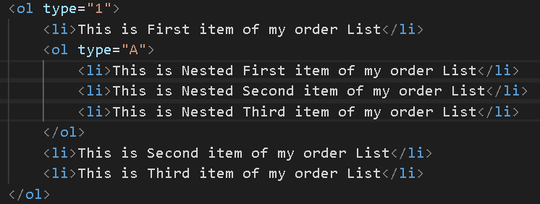  
        Shows  
        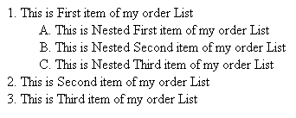
    - Tables  
      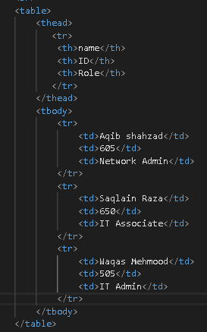  
      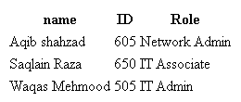
  + Lec8-HTML Forms
    - <form action=”backend.php”>Forms </form>
    - Forms
      * Input:text
      * Input:email
      * Input:email
      * Input:number
      * Input:checkbox
      * Input:radio
      * Select
        + Option
      * Textarea
      * Input:reset
      * Input:submit
    - <div></dive>: used to make a block which occupi space and new data starts after that.
    - Labels  
      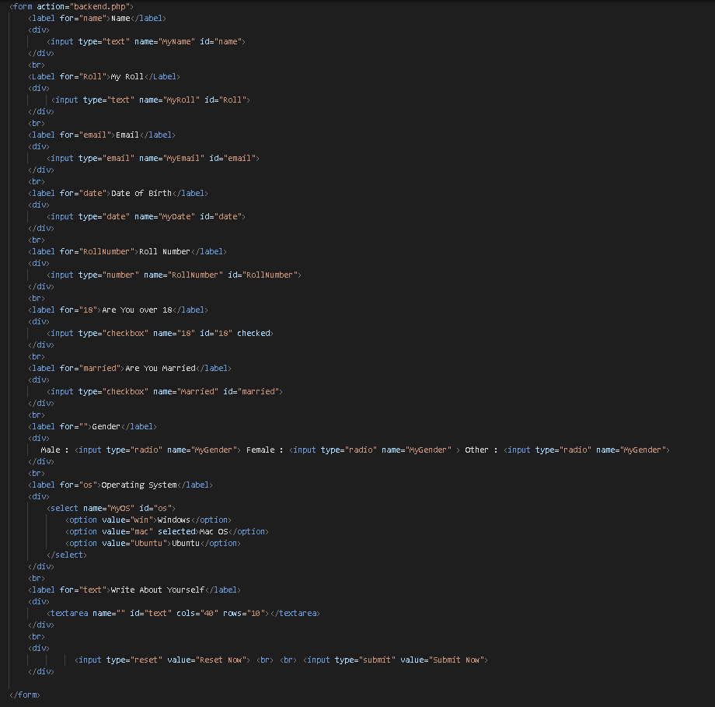  
      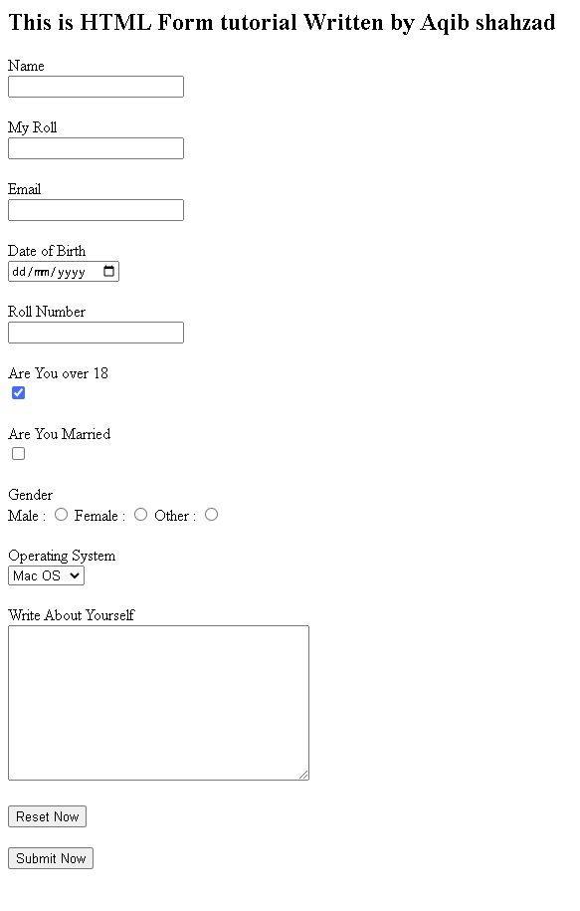
  + Lec9-
    - Block element : takes all place in horizental, e.g. <p></p>   
      e.g.: <p>This is a peragraph</p> <p>This is also a peragraph</p>  
      shows 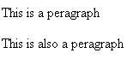
    - Inline Element: Takes only needed space in horizental e.g.: <span></span>  
      e.g.: <span>This is spane</span> <span>This is also a span </span>  
      shows   
      To write in line use inline tag such as <a>,<span>,<strong>, <em> <img> instead of block element such as <p>, <div>, <li> which takes whole horizental space.
  + Lec10-IDs and Classes  
    One ID can only be assign to one Block and one block can only be assign only one ID. Whereas one Class can be assigned to multiple blck and a one can be assigned multiple classes.
    - IDs: Assign one Uniqe ids to a block which helps to format using css and call for any function from js.
    - Class: assign one or more classes to any block to implement changes on that block which is define for the class.
    - Emmets of Creating blocks with classes and ids  
      Used “.” for class and “#” for ID.
      * To add span of a class “RedBG” write “span.RedBG” and enter it will write   
        <span class="RedBG"> </span>
      * To add span of id “NewID” write “span#NewID” and eter it will write  
        <span id=”NewID”></span>
      * To add Multiple Classed: type “div.RedBG.WhiteBD” it will add   
        <div class="RedBG WhiteBD"></div>
      * Emmet Takes <div> as default tag. E.g.: if i write “.black” it will create   
        <div class="black"></div>
      * To add div of id “black” type “.black” it will create   
        <div id="black"></div>
      * To add 4 times of div with classes of “classA classB ClassC” type “.classA.ClassB.ClassC*4” it will create   
        <div class="classA ClassB ClassC"></div>  
        <div class="classA ClassB ClassC"></div>  
        <div class="classA ClassB ClassC"></div>  
         <div class="classA ClassB ClassC"></div>
  + Lec11-Entities  
    used to add spaces, by default html only show one spaces.
    - &nbsp: non breaking space: used to print space, but not recomended to used this because we will be using margins , padings , css selectors and css properties.
    - Print tags using &lt;tag&gt; : if you write <p>The tag to write pera is &lt;p&gt; </p> it will show The tag to write pera is <p>
    - Html etities reference also used to print special char and signs.  
      E.g.: 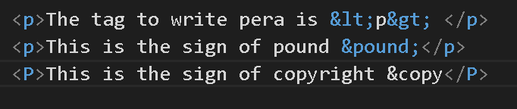  
      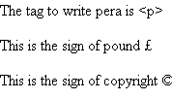
    - Blank Char/ Empty char: &#8203 : is an emty char used to print or send empty char where empty is not allowed or something.
  + Lec12-Semantic Tags:  
    The HTML semantics refers to the tags that provide meaning to an HTML page rather than just presentation. It makes HTML more comprehensible by better defining the different sections and layout of web pages.  
    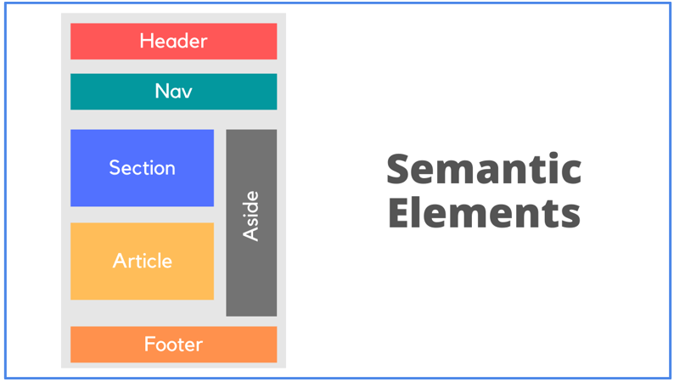
    - Semantic Means giving meaning to somethings, Semantic tags provide web pags additional information of that code block. A semantic element clearly describes its meaning to both the browser and the developer.  
      Examples of semantic elements: <form>, <table>, and <article> - Clearly defines its content.
      * <article>
      * <aside>
      * <details>
      * <figcaption>
      * <figure>
      * <footer>
      * <header>
      * <main>
      * <mark>
      * <nav>
      * <section>
      * <summary>
      * <time>
      * <details>
    - Non Semantic Element: Examples of non-semantic elements: <div> and <span> - Tells nothing about its content.
  + Lec13-CSS  
    CSS gives style to raw HTML. CSS stands for Cascading Style Sheets. CSS is used to give style to our web pages. CSS is used to make websites responsive. HTML is used to structure a website. CSS takes responsibility of design. It helps pages responsive according to different devices such as Laptop, mobiles and tabs.
    - CSS Syntax  
      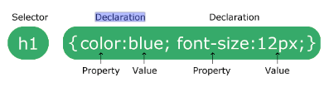  
      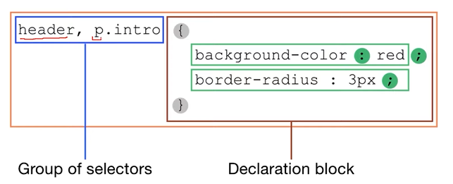
      * Selector: where ( it define whare changes applied)
        + Property: what
        + Value: How
    - Ways to add CSS to Markup (HTML)
      * Inline CSS: CSS is added to the elements directly using Style attribute
      * Internal CSS: CSS is kept inside the head tags in tags
      * External CSS: CSS is kept separately inside a .css style sheet. Its Two step process
        + Write separtate CSS file
        + Include CSS file to markup.
    - Precedence of Stype
      * Precedence of Style Between Inline and Internal CSS  
        Inline CSS have more precedence
      * Precedence of Style between Internal vs External CSS  
        Whichever is written Below (or written after) has more precedence
      * !important;  
        If we write “!imporant” in any style that style will have highest precedence, no other can overwrite it.
  + Lec14-Selector  
    Selector used to select where style applied, we can select one or multiple selector
    - Types of Selectors
      * CSS element Selector  
        Selecting with element such <p>, <div>   
        Syntac for elecpt p personilization:  
        p{  
         color : red;   
        }
      * CSS id Selector  
        for id=”SecondPera” personilization:  
        #{  
        color: yellow;  
        }
      * CSS class Selector  
        for Class=RedBg” personilization:  
        .RedBg{  
         background-color: red;  
        }
      * CSS grouping Selector
    - Comment in CSS   
      /*This is the Syntax of writting comments in CSS*/
  + Lec16-Developer Tools
    - Chrome’s Inspect feature explore